Module 5 HTML5

1 What are the new tags added in HTML5?

* <figure>
* <article>
* <main>
* <nav>
* <footer>
* <header>

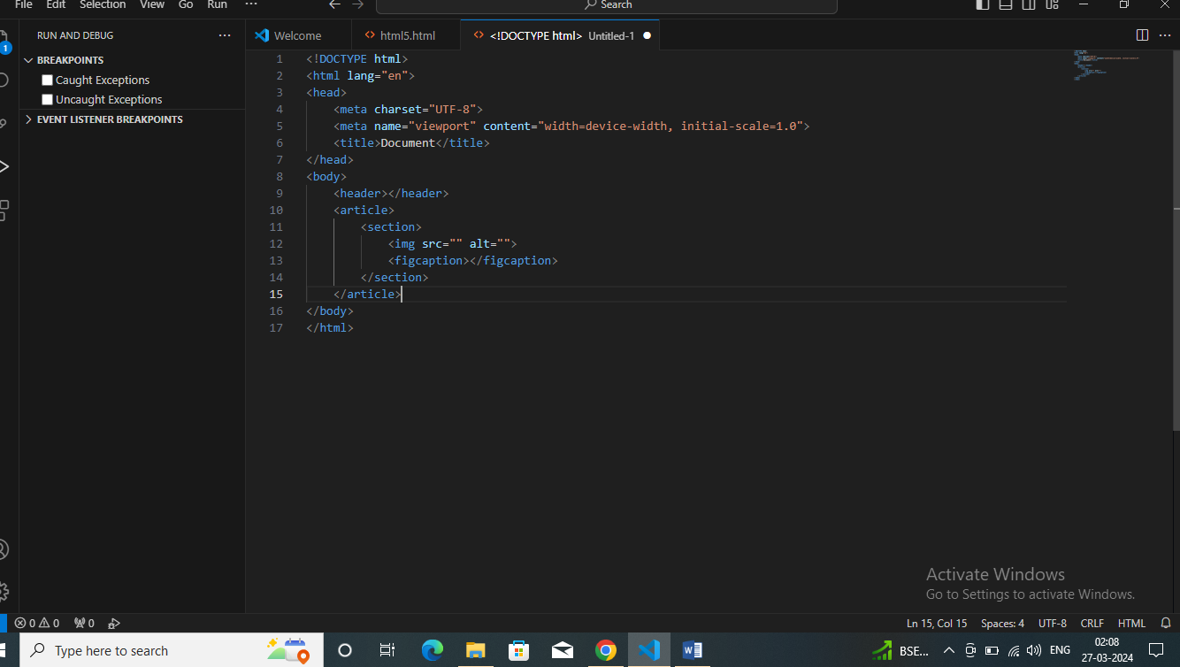

2 How to embed audio and video in a webpage?

To embed audio in webpage we use <audio> tags

<html>

<head>

<title>Page Title</title>

</head>

<body>

<h3>click play button to play audio</h3>

<audio src= “./test.mp3” controls></audio>

</body>

</html>

3 Semantic element in HTML5?

Semantic elements have meaningful names that tell about the type of content. For example header, footer, table.

<header>

<article>

<footer>.

<head>

        <title>Header Tag</title>

        <style>

            h1, h3 {

            Color:#006400;

            Text-align:left;

            margin-bottom:0px;

            }

            p {

            font-size:25px;

            text-align:left;

            margin-top:0px;

            }

        </style>

    </head>

4 Canvas and SVG tags

Canvas and SVG tags are mostly use on clear the picture quality.

<canvas>

Canvas id= “my canvas”

Width=

Height=

Style=

<!DOCTYPE html>

<html lang="en">

<head>

    <meta charset="UTF-8">

    <meta name="viewport" content="width=device-width, initial-scale=1.0">

    <title>Document</title>

</head>

<body>

    <canvas id="new canvas" width="150"

        height="150" style="border:1px">

    </canvas>

    </body>

</html>

SVG

Svg tag stands for scalabe vector graphics.

<!DOCTYPE html>

<html lang="en">

<head>

    <meta charset="UTF-8">

    <meta name="viewport" content="width=device-width, initial-scale=1.0">

    <title>Document</title>

</head>

<body>

    <sag id="svgelem" height="200">

        <circle id="greencircle" cx="60"

           cy="60"r=50>

        </circle>

    </sag>

    </body>

</html>